***Percussion Part***

For the duration of the piece you are asked to play this part without any regard to the other performers. There is no conductor and, for the most part, there is no coordinated ensemble work.

The notation is written entirely without meter. Pages read from top to bottom and left to right. Space relates loosely to time. The presence of a staff indicates that a sound is being produced or sustained while the absence of one indicates silence. Staff cutoffs ask that any resonating instruments be dampened. Blank space between events (potentially including entire blank pages) indicates loosely proportional pauses. Although there is no strictly defined timecode and page lengths will vary widely, the majority of pages should take between 40 and 80 seconds to play through.

Occasional instructions written inside boxes call for special actions such as listening to and imitating other performers or repeating passages. If any boxed instruction asks you to wait until you hear something happen before proceeding, you should continue regardless if more than about a minute passes.

To begin the work, every person begins at the top of their first page. When you reach the end of your part, simply stop playing. The performance will be over once no performer has made a deliberate sound for over a minute. If you are the last performer playing at the end of the piece, boxed instructions asking you to wait or listen to other performers should be ignored.

The part uses 9 percussion instruments as indicated below. If the exact instruments are not available, appropriate instrument substitutions may be made at your discretion. The different notehead shapes relate only to the instruments they correspond to and have no bearing on duration.

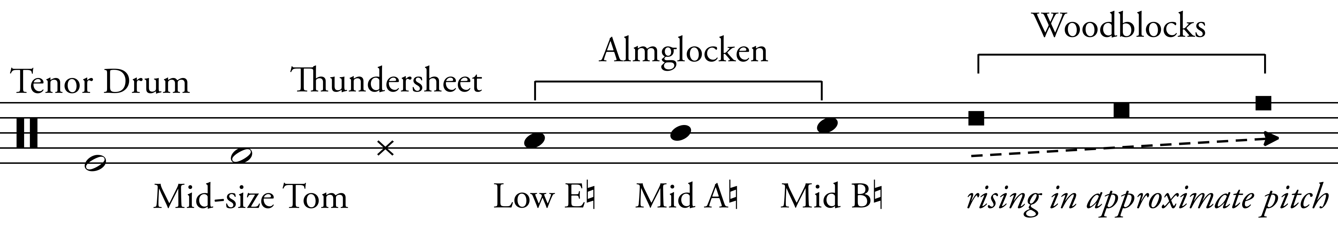

Hard yarn, soft yarn, and soft rubber beaters will be used.